Southern New Hampshire University

CS 405 Secure Coding

Professor Mike Prasad

Student: Tyanna Prince

11/18/2022

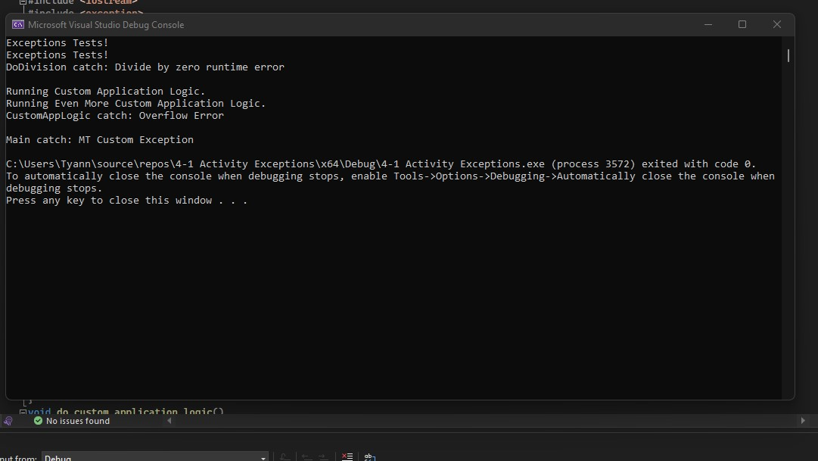

This assignment was challenging but with the help of searching to clear the confusion I was having with the error I was coming across helped me solve where my problem was. I went back through the module with additional search reading to really grasp what I needed to do for this assignment. In the end, I did everything correct but I had an error in my code. I was missing an } at the end of one of my statements. After fixing this error the test ran perfectly.